Tic-Tac-Toe



Submitted by:
- Munawar Ali – NUM-BSCS-2024-60
2. Muhammad Hamza– NUM-BSCS-2024-48

Computer Organization and Assembly Language

Department of Computer, Namal University Mianwali

1. Introduction

This project implements a Tic-Tac-Toe game using Assembly language with the MASM32 assembler. It demonstrates key computer organization concepts like memory addressing, registers, and system calls. The game involves user input handling, turn-based logic, and checks for winning conditions. By building this project, we gain a deeper understanding of low-level programming and the interaction between software and hardware.

2. Problem Statement
The problem addressed by this project is the creation of a Tic-Tac-Toe game using assembly language, which requires simulating a basic game environment with minimal resources. The challenges include implementing user input handling, displaying the game board, ensuring proper turn-taking between two players, and checking for win conditions. The program must also manage error handling for invalid inputs and filled positions, all while working within the constraints of assembly language, which requires direct memory manipulation and limited high-level abstractions.

3. Proposed Solution
To address the problem of creating a Tic-Tac-Toe game using assembly language, the solution involves building a game that can handle player inputs, manage game turns, and check for win conditions. The assembly code uses memory locations to represent the game board, allows players to input their moves, and checks for winning conditions after each move.

3.1 Flow Diagram

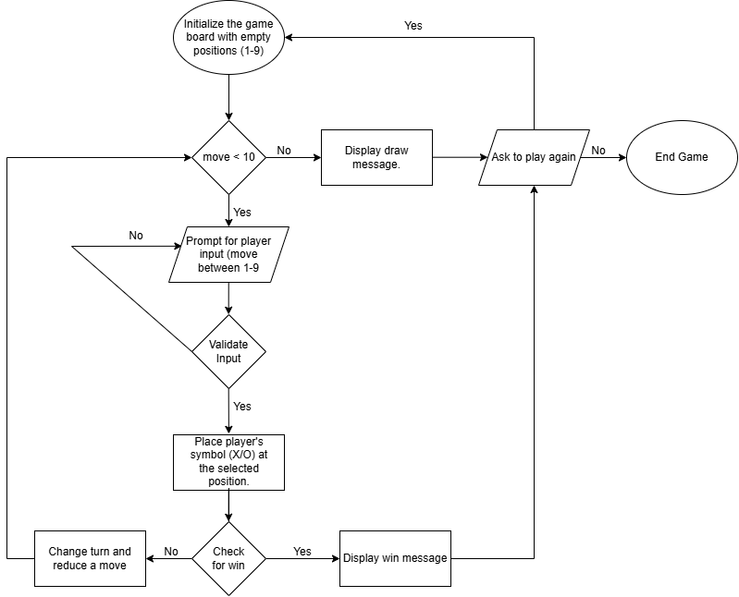3.2 Pseudo Code

Reset Board:
- Purpose: Reset the game board to its initial state.
- Process: Initialize each cell of the game board with values 1-9.

Print Board:
- Purpose: Display the current state of the game board.
- Process:
  - Print each row of the game board.
  - Print horizontal lines to separate rows.
  - Display instructions for valid inputs.

Player Input:
- Purpose: Capture the current player's input.
- Process:
  - Display the current player's symbol (X or O).
  - Prompt the player to enter a value between 1-9.
  - Read and store the input.

Update Table
- Purpose: Update the game board based on the player's input.
- Process:
  - Compare the input value against valid positions.
  - If the position is empty:
    - Update the board with the player's symbol.
  - If the position is filled:
    - Prompt the player to select another position.
  - If the input is invalid:
    - Display an error and prompt for a valid input.

Change Turn
- Purpose: Alternate between players after each valid move.
- Process:
  - If the current player is X, switch to O.
  - If the current player is O, switch to X.

Check Winner
- Purpose: Determine if a player has won the game.
- Process:
  - Check all rows for matching symbols.
  - Check all columns for matching symbols.
  - Check both diagonals for matching symbols.
  - If a match is found:
    - Announce the winner.
    - Prompt to play again or end the game.
  - If no winner is found, continue the game.

Main Logic
- Purpose: Control the game flow.
- Process:
  - Initialize the game with player X.
  - Repeat for up to 9 turns:
    - Clear the screen.
    - Display the game title and board.
    - Capture and validate player input.
    - Update the board.
    - Check for a winner.
    - Switch turns.
  - If all turns are completed without a winner:
    - Announce a draw.
    - Prompt to play again or end the game.

Game Title
Purpose: Display the title screen.
Process: Print ASCII art of the TIC TAC TOE game.

3.3 Assembly Code
Include irvine32.inc

.data
playagain byte " If you want to play again press 1 or enter any key to end the game ",0
strtingmsg byte " TIC TAC TOE ",0
ticmsg0 byte " ________________________________________________________________________________ ", 0
ticmsg1 byte " | ______ * ___ _____ __ ___ _____ ____ ____ | ", 0
ticmsg2 byte " | | | / | //\\ / | | __ | | | ", 0
ticmsg3 byte " | | | | | //--\\ | | ||__|| |---- | ", 0
ticmsg4 byte " | | | \___ | // \\ \___ | |____| |____ | ", 0
ticmsg5 byte " |________________________________________________________________________________| ", 0
brdmsg byte "Enter the value between 1-9 according to the above table",0
horizontalLine BYTE '-----------',0
row1 BYTE ' 1 ', '|', ' 2 ', '|', ' 3 ' ,0
row2 BYTE ' 4 ', '|', ' 5 ', '|', ' 6 ' ,0
row3 BYTE ' 7 ', '|', ' 8 ', '|', ' 9 ' ,0
player1 byte 'X'
player2 byte 'O'
value byte ?
value2 byte ?
againmsg byte " The place is already filled please select another place ",0
againmsg2 byte " wrong input!!! Enter the correct number ",0
winmsg byte " Player Win ",0
drawmsg byte " Match draw ",0
plmsg byte " PLAYER's TURN ",0

.code
reset PROC
mov esi, offset row1

mov [esi+1], '1'
mov [esi+5], '2'
mov [esi+9], '3'

mov esi, offset row2
mov [esi+1], '4'
mov [esi+5], '5'
mov [esi+9], '6'

mov esi, offset row3
mov [esi+1], '7'
mov [esi+5], '8'
mov [esi+9], '9'
ret
reset endp
boxprinter PROC
call crlf
call crlf
mov edx, OFFSET row1
call WriteString
call crlf
mov edx, OFFSET horizontalLine
call WriteString
call crlf
mov edx, OFFSET row2
call WriteString
call crlf
mov edx, OFFSET horizontalLine
call WriteString
call crlf
mov edx, OFFSET row3
call WriteString
call crlf
mov edx, OFFSET horizontalLine
call WriteString
call crlf
mov edx,offset brdmsg
call WriteString
call crlf
ret
boxprinter ENDP

inputPlayer PROC uses eax
mov edx,offset player1
call writechar
mov edx,offset plmsg
call WriteString
call readchar
call writechar
mov value,al
call crlf
ret
inputPlayer ENDP

updatetable PROC
cmp value,'1'
je replace1
cmp value,'2'
je replace2
cmp value,'3'
je replace3
cmp value,'4'
je replace4
cmp value,'5'
je replace5
cmp value,'6'
je replace6
cmp value,'7'
je replace7
cmp value,'8'
je replace8
cmp value,'9'
je replace9
jmp again2
replace1:
mov esi, offset row1
mov value2, 'X'
mov bl, [esi+1]
cmp bl, value2
je again

mov value2, 'O'
cmp bl, value2
je again

mov esi,offset row1
mov [esi+1],al
jmp rr
replace2:
mov esi, offset row1
mov value2, 'X'
mov bl, [esi+5]
cmp bl, value2
je again

mov value2, 'O'
cmp bl, value2
je again

mov esi,offset row1
mov [esi+5],al
jmp rr
replace3:
mov esi, offset row1
mov value2, 'X'
mov bl, [esi+9]
cmp bl, value2
je again

mov value2, 'O'
cmp bl, value2
je again

mov esi,offset row1
mov [esi+9],al
jmp rr
replace4:
mov esi, offset row2
mov value2, 'X'
mov bl, [esi+1]
cmp bl, value2
je again

mov value2, 'O'
cmp bl, value2
je again

mov esi,offset row2
mov [esi+1],al
jmp rr
replace5:
mov esi, offset row2
mov value2, 'X'
mov bl, [esi+5]
cmp bl, value2
je again

mov value2, 'O'
cmp bl, value2
je again

mov esi,offset row2
mov [esi+5],al
jmp rr
replace6:
mov esi, offset row2
mov value2, 'X'
mov bl, [esi+9]
cmp bl, value2
je again

mov value2, 'O'
cmp bl, value2
je again

mov esi,offset row2
mov [esi+9],al
jmp rr
replace7:
mov esi, offset row3
mov value2, 'X'
mov bl, [esi+1]
cmp bl, value2
je again

mov value2, 'O'
cmp bl, value2
je again

mov esi,offset row3
mov [esi+1],al
jmp rr
replace8:
mov esi, offset row3
mov value2, 'X'
mov bl, [esi+5]
cmp bl, value2
je again

mov value2, 'O'
cmp bl, value2
je again

mov esi,offset row3
mov [esi+5],al
jmp rr
replace9:
mov esi, offset row3
mov value2, 'X'
mov bl, [esi+9]
cmp bl, value2
je again

mov value2, 'O'
cmp bl, value2
je again

mov esi,offset row3
mov [esi+9],al

rr:
call clrscr
call boxprinter
ret
again2:
call clrscr
call boxprinter
mov edx, offset againmsg2
call WriteString
call crlf
call inputPlayer
jmp updatetable
again:
call clrscr
call boxprinter
mov edx, offset againmsg
call WriteString
call crlf
call inputPlayer
jmp updatetable
updatetable endp

changeturn PROC
cmp al, player1
je chng
mov al, player1
call writechar
jmp e
chng:
mov al, player2
call writechar
e:
ret
changeturn ENDP

win PROC uses eax
; Check rows
mov esi, offset row1
mov bl, [esi+1]
cmp bl, [esi+5]
jne x
cmp bl, [esi+9]
je w

x:
mov esi, offset row2
mov bl, [esi+1]
cmp bl, [esi+5]
jne y
cmp bl, [esi+9]
je w

y:
mov esi, offset row3
mov bl, [esi+1]
cmp bl, [esi+5]
jne check_columns
cmp bl, [esi+9]
je w

check_columns:
; Check columns
mov esi, offset row1
mov bl, [esi+1]
cmp bl, [esi+1 + 12] ; Check same column in row2
jne check_column2
cmp bl, [esi+1 + 24] ; Check same column in row3
je w

check_column2:
mov esi, offset row1
mov bl, [esi+5]
cmp bl, [esi+5 + 12] ; Check same column in row2
jne check_column3
cmp bl, [esi+5 + 24] ; Check same column in row3
je w

check_column3:
mov esi, offset row1
mov bl, [esi+9]
cmp bl, [esi+9 + 12] ; Check same column in row2
jne check_diagonals
cmp bl, [esi+9 + 24] ; Check same column in row3
je w

check_diagonals:
; Check diagonals
mov esi, offset row1
mov bl, [esi+1]
cmp bl, [esi+5 + 12] ; Check middle of the diagonal
jne check_diagonal2
cmp bl, [esi+9 + 24] ; Check end of the diagonal
je w

check_diagonal2:
mov esi, offset row1
mov bl, [esi+9]
cmp bl, [esi+5 + 12] ; Check middle of the other diagonal
jne e
cmp bl, [esi+1 + 24] ; Check end of the other diagonal
je w
jne e

w:
mov edx, offset winmsg
call writechar
call WriteString
call crlf
mov edx, offset playagain
call WriteString
call readint
cmp eax, 1
je start
exit
start:
call reset
call main

e:
ret
win ENDP

title1 PROC
mov edx,offset ticmsg0
call WriteString
call crlf
mov edx,offset ticmsg1
call WriteString
call crlf
mov edx,offset ticmsg2
call WriteString
call crlf
mov edx,offset ticmsg3
call WriteString
call crlf
mov edx,offset ticmsg4
call WriteString
call crlf
mov edx,offset ticmsg5
call WriteString
ret
title1 endp

main PROC
mov al,player1
movzx ebx,al
mov ecx,9

l1:
call clrscr
call title1
call crlf
call boxprinter
call inputPlayer
call updatetable

call clrscr
call boxprinter
call win
call changeturn
loop l1
jnz r
call clrscr
call boxprinter

mov edx, offset drawmsg
call WriteString
call crlf
mov edx, offset playagain
call WriteString
call readint
cmp eax, 1
je start
exit
start:
call reset
call main
r:
exit
main ENDP
invoke ExitProcess, 0
end main

4. Results and Findings
Game Functionality
- The code successfully implements a TIC TAC TOE game where two players can take turns to play.
- It handles player inputs, updates the game board dynamically, and alternates turns between Player 1 (X) and Player 2 (O).
Win and Draw Detection
- The program correctly identifies win conditions by checking rows, columns, and diagonals.
- If no win condition is met after nine moves, the game declares a draw.
Input Validation
- The code validates player inputs to ensure only values between 1-9 are accepted.
- If a player selects an already occupied position, the program prompts them to choose a different spot.
Replay Option
- At the end of each game (win or draw), players are prompted to either replay the game or exit.
Board Display
- The board is displayed clearly, with updated values after each move, ensuring players can easily track the game state.
Error Handling
- Incorrect inputs or invalid moves are handled gracefully with appropriate error messages.
Limitations
- The game does not have AI or single-player functionality; it is strictly for two players.
- The interface is text-based and lacks graphical elements, which might reduce engagement for modern users.

5. Conclusion
The TIC TAC TOE game implemented in assembly language is a functional, text-based program that successfully demonstrates core programming concepts such as input handling, condition checking, and procedural logic. The program achieves the following:
Core Functionality:
- Enables two players to take turns and play the game with proper input validation and error handling.
- Provides a clear and dynamic display of the game board after each move.
Game Flow Management:
- Detects win conditions accurately and announces the winner.
- Handles edge cases like invalid inputs or selecting already occupied positions.
- Declares a draw if no player wins after nine moves.
User Interaction:
- Allows players to replay the game or exit after the conclusion of each round.
While the program is functional and meets its objectives, it is limited by its text-based nature and lack of advanced features, such as single-player mode or a graphical interface. Nonetheless, it effectively demonstrates structured programming, data manipulation, and the basics of game logic in assembly language.

